IT2654 Systems Administration & Security

Tutorial 3

Discuss within your groups and prepare the answers to be presented in class.

- What is RAID and what are its objectives?
Redundant Array of Independent Disk.

It prevents data loss since you copy your file 2 times. For RAID 1, if one file fails, you still have another file. However, you still need to backup your data in case the second file fails.
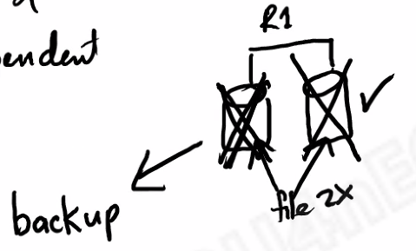
It also lengthens disk lifespan. Usual hard disk lifespan is 3-5 years. If you keep using only 1 hard disk, it might last only 3.5 years. But by adding another hard disk, you can write half of the file to 1 disk and the other half to another disk, thus reducing the intensity that the disks are being used, ultimately reducing wear and tear on the disk (stripping)
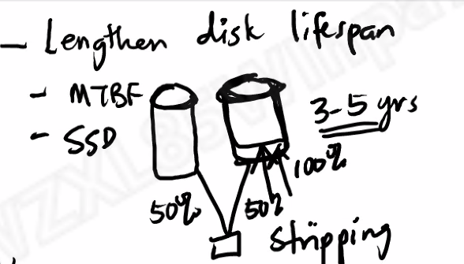
It is also fault tolerant. If you can prevent hard disk from failing, the system can continue longer.

- Describe the various types of RAID available in Windows Server 2016.

Name of RAID | Fault tolerant? | Min Disk Needed | Max Failure
0 (stripping) | No | 2 | 0 (since not fault tolerant)
1 (mirror) | Yes | 2 | 1
5 (stripping with parity) | Yes | 3 | 1
6 (stripping with double parity) | Yes | 4 (but in actual Windows Server 2016 implementation: 7 needed) – answer for tests: 7 | 2
10 (1+0) (stripping with mirroring) | Yes | 5 – answer for tests: 4 | 2
3 way mirror | Yes | 5 | 2

Why RAID 6 is the best:
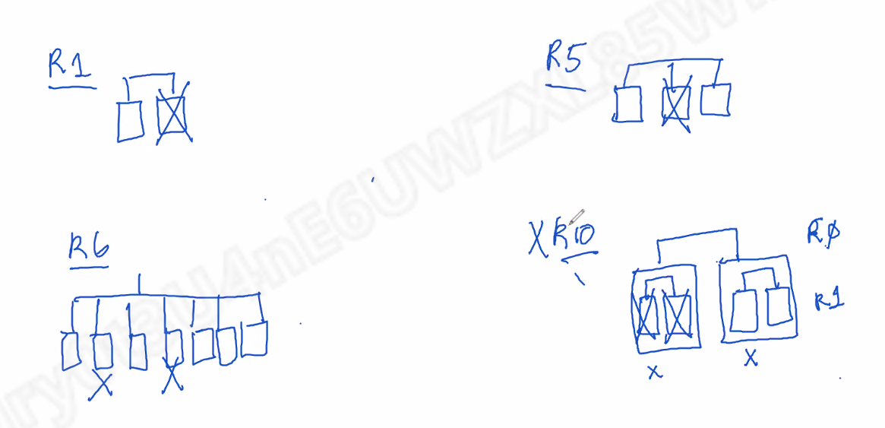
For RAID 10, if the failure is at the 2 mirrors, your RAID 10 will die. But for RAID 6, you have a better chance of not killing your RAID 6 since any 2 hard disks can die.

- What are some advantages of a Dynamic Disk?
- Extension/ spanning of NTFS Volume
- Can configure RAID volumes for fault tolerance and performance
- Can reactivate missing or offline disks
- Compression, encryption
- Can change disk settings without restarting computer
- Disk quota
- Storage spaces virtual disk

Try to keep C: drive to basic since its hosting the OS. Basic is easier to manage for operating systems. Basic to dynamic easy to convert but dynamic to basic is difficult to convert since there will be data loss.
- Explain the following concepts:

  - Mounting a volume

Mounting a drive is an alternative to assigning it a drive letter. A mounted drive is represented as a folder with a normal path.

A: and B: is used for floppy disks. C: is what we use now for our windows OS. Since there are only 26 letters, we can only have 26 drives.

Mounting a volume: instead of assigning a letter, we use a drive letter in order to overcome the 26 limit and also make it easier for backup. Path access is also more convenient.

However, to mount a drive, must be on an NTFS volume and there must be an empty folder

  - Disk defragmentation

Free disk space eventually becomes fragmented as files are created and removed. This results in slower access and higher disk wear. Defragmentation attempts to place files in contiguous areas. Defragmentation should be done periodically.

Fragmented:
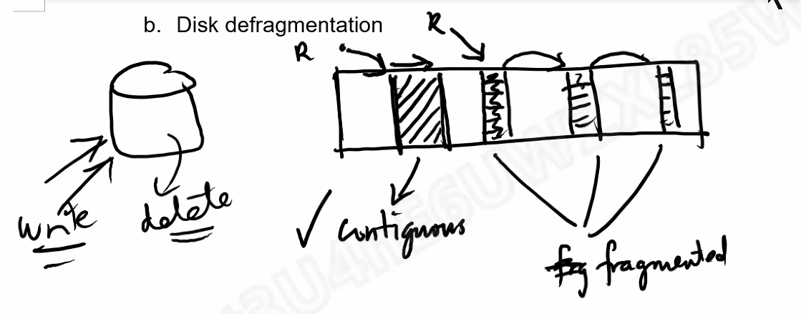

Defragmented:
